**INTRODUCTION TO MICROSOFT OFFICE**

**(PART 1 MICROSOFT WORD)**

**LAB # 03**



**Fall 2021**

**CSE101L Computer Programming Lab**

Submitted by: **ALI ASGHAR**

Registration No. : **00450**

Class Section: **C**

“On my honor, as student of University of Engineering and Technology, I have neither given nor received unauthorized assistance on this academic work.”

Student Signature: ______________

Submitted to:

**Engr. Abdullah Hamid**

December 9, 2021

Department of Computer Systems Engineering

University of Engineering and Technology, Peshawar

**Social Media Interactions With the wide World**

**A Research done by Students of UET Peshawar**

**Abstract:**

Social Media connects around 2.2 Billion of the around 7 Billion people that inhabit the planet. Other than just connecting friends and family it also provides the potential to connect people according to one’s need. Whether it is a person who wishes to find a someone to get his assignments done, build a website for him, fix his car or even to find people of similar interest like a support group for cancer, social media has made all of these things possible.

Our aim with this project was to build an application that brings together service providers and clients onto a single platform, using that the very connections that you already have on the most widely used social media platform i.e. Facebook. The application uses your social media connections to let you know of the people closest to you who have a particular set of skills that you may require.

**LITERATURE REVIEW:**

Different areas of mathematics have played vital roles in solving various problems that are related to different fields, one such area is graph theory which is used in structural models. Graph theory was first put into practice properly when solving the Koinsberg bridge problem in 1735, in which a person must pass through each of the seven bridges that connect a city and still be inside the city at the end. Later Euler studied the problem of Koinsberg bridge to construct a structure to solve the Eular problem. Further work on graph theory was done by A.F Mobius came up with the idea of complete and bipartite graphs in 1840[2].

A research was conducted in Malaysia amongst job seeker who used Social Networking Sites(SNS). Snowball sampling approach was used to distribute around 190 questionnaires to job seekers and the data was analyzed using the Structural Equation Modelling Technique. The study showed that the most famous Social Networking Site amongst them was Facebook followed by Friendster and then LinkedIn. Only 18.4% of the respondents used SNS for job searches, suggesting that this was not a major tool for job searches amongst those in Malaysia.

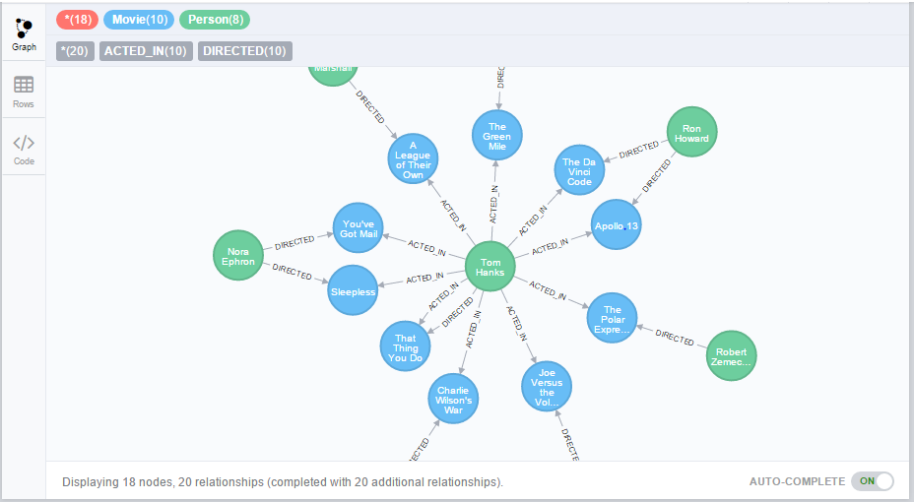

There are plenty of applications of Graph Theory in Computer Science. They have been used to solve many complex problems like Shortest path algorithm in a network, Finding a minimum spanning tree, Location graph planarity, Finding adjacency of matrices., Algorithms for Depth First Search and Breadth First Search[2].

**References:**

[1] Goal Directed Shortest Path Queries Using Precomputed Cluster Distances

Jens Maue, Peter Sanders, and Domagoj Matijevic, 2006

[2] APPLICATIONS OF GRAPH THEORY IN COMPUTER SCIENCE AN OVERVIEW

S.G.Shirinivas, S.Vetrivel, Dr. N.M.Elango